

Software Requirements Specification

Version 1.0

<<Annotated Version>>

Nov25, 2017

**On Line Medicine Order System**

Prepared by: Khandakar Amir Hamza

ID:143014053

Group 5

University of Liberal Arts Bangladesh

# Contents of Table

Project Backgrund…………………………………….

Purpose…………………………………………..

GETTING STARTED………………………………………………4

1. LOGGING IN TO Drug Mart………………………………..4

2. Overall Description………………………………………….5

2.1 Product Perspective…………………………………………6

2.2 Product Functions ………………………………………….7

2.3 User Classes and Characteristics………………………… 8

2.4 Operating Environment……………………………….. 9

2.5 Design and Implementation Constraints……………. 10

3. MAINTENANCE……………………………………………..10

3.1. PREFFERANCES…………………………………………...10

* 1. GENERAL………………………………………………….10

3.3 SALES………………………………………………………11

3.4 SALES RETURN…………………………………………...11

3.5 PURCHASE………………………………………………….11

3.6 PURCHASE RETURN……………………………..………..11

3.2. INTERFACE SETTINGS………………………………….....11

3.3. ADJUSTMENT………………………………………….……11

4. MANAGE………………………………………………………..12

4.1. GROUP………………………………………………………..12

4.2. USER……………………………………………………….….12

5. SALE…………………………………………………………….12

5.1. CASH SALE…………………………………………………...12

5.2. CREDIT SALE…………………………………………………12

5.3. SALE RETURN……………………………………………......12

6. HOW TO SAVE AND POST SALE AND PURCHASE INVOICES ……13

7. REPORTS………………………………………………………………… 13

### Conclusion……………………………………………………………13

References…………………………………………………………….13

Project Background

Online Pharmacy management system is a process of managing the medicine selling store stock. Its help selling and buying process of a medicine store. Selling process is involved because to relate the alert warning message to the stock condition.

This software helps you to track all the profits, loss, profitable clients and products of medical shop moreover it’s a medical shop accounting software.

Purposes

1. Give pharmacist alert about the stock of the medicine.

2. To provide a secure system application

3. To help in decision making

4. To provide a systematic medicine inventory

1. Urgent order distributor.

Some important things before using software

## GETTING STARTED

Here we are describing a bit about our software, in this manual in case of any other confusion or query please does contact us.

Before doing any sale or purchase or start working with our software u have to keep in notice some points to have a better understanding of using our software:

* U must have entered some items in the software so that you can sell or purchase
* U must have created a group i.e. administrator, salesman etc.
* In that group you had to create some specified user accounts i.e. if for example you have created a group named administrator and u have given all the rights to that group now what is required to do is u should create different account in that group so that every person having administrative rights can log on with his/ her specified account.
* Main heading(Functional Requirements)
* Sub heading(Non-Functional Requirements)

## 1. LOGGING INTO (DM)

Click the (DM) icon at your desktop. A tab would be opened which asks your user name and password. Inter your name and password and press ok. Then Customer Registration their pharmacy.

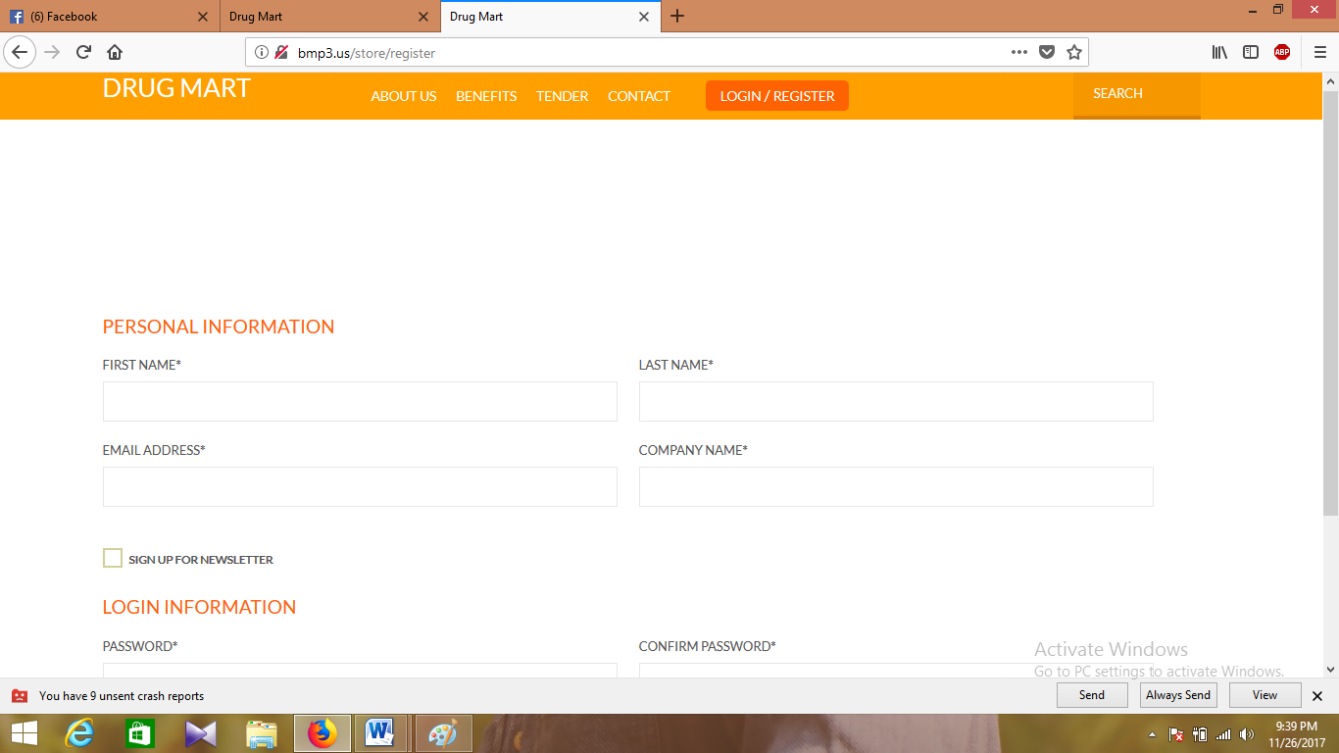

# 2 Overall .Description

## 2.1 Product Perspective

Drugs selling processes are handled manually today.It is very difficult to manage it s all process such as selling, ordering, payment etc.

So now we require a strong software based System which helps the pharmacists in order to make their process easy.This is newly design System to the Organization The System have ADMIN who has full rights with regards to managing resources such as check the Login Information, Update Data, Access to data base.

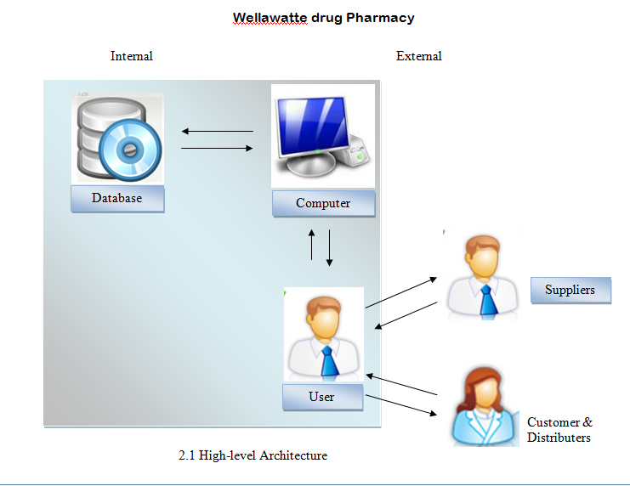

## 

## 2.2 Product Functions

1. *Handle stock details*

*details about drugs, purchase drugs(drug id, Name, Mf company&date , Category, quantity, Expire date and Supplier id)

* Need those reports-Stock Report, purchase report, and reorder level report.

02. *Handle stock distribution*

* take report about stock distribution .

03. *Handle stock returns & distributed stock return*

* Need to save returns drugs details with drug id, Drug Name, Return quantity, supplier id, distributor id.

04. *Handle supplier details*

* Need to save details about supplier with supplier id, name, address, telephone

* User can find details about supplier by giving supplier id.

05. *Handle cash billing*.

*simply inserting drug details can generate a customer bill

06. *Handle staff details & staff salaries.*

*save employees details with Employee is, name, address, Telephone no, Basic.

* Calculate employee monthly salary

*Administrator can view Salary report.

07. *Handle financial detail.*

* Handle all financial detailsindatabase.

* Administrator can get report about the monthly profit details by giving the relevant month.

## 2.3 Manage

Manager has the right to Add, Delete, update about the information of Employers.

There are two different users who will be using this Product:

* Manager Who will be acting as the Administrator
* WDP Employers who get details from the System and insert details to system

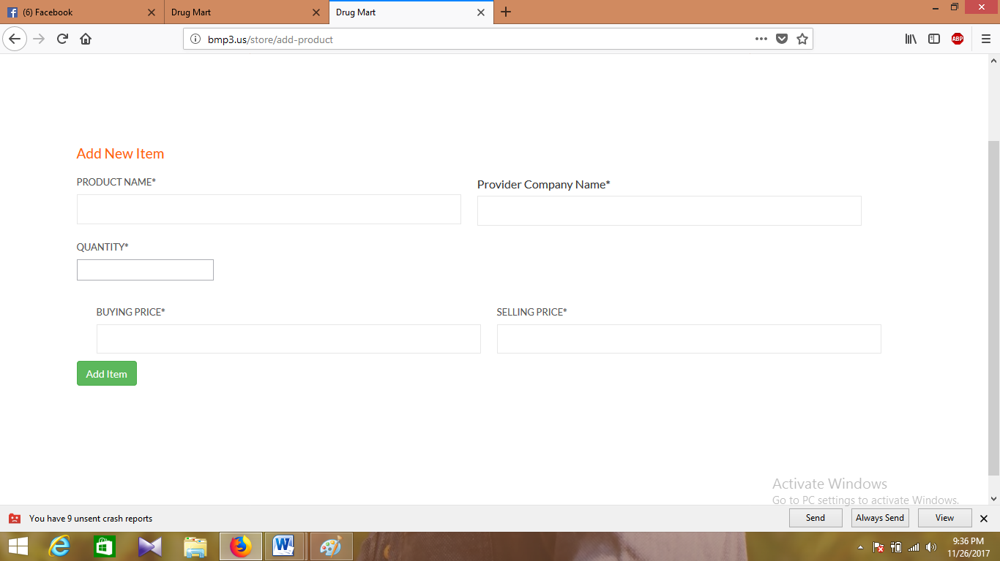

The functions that are available to the Manager are:

* Insert, Update, Delete and Find Drugs details.
* Insert Purchase details.
* View purchase report
* Insert, Update, Delete and Find Suppler Details.
* Insert, Update, Delete and Find Wholesale customer Details.
* Insert distribute drug details
* View distributed stock report.
* Generate all kind of Bills
* Insert, Update, Delete and Find Employee Details.
* Calculate Employee Salary.
* View employee salary.
* Insert financial details.
* View financial report.

The functions available to the WDP Employers:

* Insert, Update, Delete and Find Drugs details.
* Insert Purchase details.
* Insert, Update, Delete and Find Suppler Details.
* Handle report
* Insert, Update, Delete and Find Wholesale customer Details.
* Insert distribute drug details
* Generate all kind of Bills

## 2.4 Operating Environment

* *Product Operate Environment (windows xp,vista,7,8,10)-*

Because pharmacy used the XP as the O/S so we must to make Windows

.

* *Database (MySQL 5.1)-*

We use MySQL 5.1 as Our Data base so also run this S/W Application We need to Install Data base to the client pc as well.

* Hardware platform –

Above mention Database, Running Environment and Operate Environment require 2.0 GHz Pentium Dual Core or higher, 1GB of RAM, VGA 32bit 800x 600 minimum resolutions.

**2.5 Design and Implementation Constraints**

Our software has two options (web based, desktop based), but we interested to our software using Desktop based environment. The reason is that which is accessible using a Web browser and any one can access from anywhere in the world via the Web, therefore the system is unsecured. It is harm full for our privacy. That is the main reason for choosing a desktop based system. For developing our software we use laravel programming language.

## 3. MAINTENANCE

In a software maintenance is the very important module. Some important parts of maintenance module will be discussed below:

3.1 GENERAL

This module deals with the default settings of the whole software. It has four main columns

* + Software default settings: it has in focus six different options that are shown i.e. header name which you want to show at the top of your software, if you want to enable alias name of the item in complete software.
  + Quick preferred search: it deals with the search as the name suggests, for example on what basis you want to search for an item i.e. manufacturer wise, alias name wise, item name wise etc.

3.2 SALES

Before start discussing about sales preferences we need to understand about sale and purchase module. Both sale and purchase window is basically divided into three parts

Header

Detail

Footer

3.3 SALES RETURN

Here u can specify your requirements regarding sales return

* You want to see item description while you enter an item for return, you want to give some remarks

in header, auto post, header for that return etc.

3.4 PURCHASE

Here you can specify purchase regarding settings.

* Purchase invoice header window column visibility preferences: again all options mentioned over

here regarding the header of the purchase window. Whatever you want to show in the header

portion of purchase will be settled over here.

* Purchase functionality preferences: these are again same as sale functionality preferences

Over here are the settings when you make an invoice and now going to save it so what option are required by you for security purposes and others.

3.5 *ADJUSTMENT*

Adjustment module in maintenance deals with the stock adjustment

It is further divided into three parts

* Increase
* Decrease
* Stock adjustment

stock adjustment is the main part of the adjustment module it is used for the purpose.

for example if u have entered the stock of some particular item in greater amount or lesser amount so u can make an adjustment by increasing or decreasing stock value or if the actual amount of item in store is different from the amount which is shown in software again stock adjustment is used to rectify the difference

## 4. MANAGE

This module deals by users. Users create accounts through that they log into the software by giving user name and password. Before you make a user you have to make a group. Each user is defined under some group. Group is made to assign rights to each user.

4.1. GROUP

In groups you create a group by some name for example administrator or salesman etc and assign rights to each group and then save it.

4.2. USER

After creating a group and assigning it rights the next step is making users through which you login under some specific group. in this module you will give a username and its password and select the group name under which you want to make this user through the drop down menu. And giving this information you will save it.

## 5. SALE

You sale your product in cash or credit form. For that you divided into two sub categories i.e. cash sale and credit sale.

5.1. CASH SALE

After making a sale you will save and post it in the same manner as you have done with purchase.

5.2. CREDIT SALE

When you make a sale where you don’t get the payment immediately you use credit sale module.

5.3. SALE RETURN

Sale return is further subdivided into

* + Credit sale return: the sales you have made in credit sale module will be returned in credit sale return. You will be asked about the invoice number to make a return so that it can be made sure that your company sells this item. The invoice number will be mentioned on the top of the receipt you have given to the customer at the time of sale.
  + Cash sale return: cash sale return is done for the sale you have made in cash form. The rest of the procedure is same as the credit sale return

6. HOW TO SAVE AND POST PURCHASE OR SALE INVOICES

After selling a product you need to save it. Then you will press the list tab. You will be shown a screen Press “no”. You will be shown a screen then you will press the “post” button. A message will be shown to you in this message box window you will give your and your password. And press “ok”.

## 8. REPORTS

This module of the software provides all reports about your sell and purchase in the time of day or month or year.

Conclusion:-

Our medicine management software for medicine selling store is the complete management software which is designed for reduce work load from a pharmacist and a medicine production company. Using this we can save money because we not need extra employee for order collect from the field .Also it saves our time.

Refrences:-

1. <https://www.capterra.com/medical-practice-management-software/>

2.http://softwares.cmsstores.com/medical-stores-shops-software-pharmacy-chemist-retail-software/